

***WWC: World Wonders Classification***

*Report*

| **ID** | **Student Name** | **E-mail** |
| --- | --- | --- |
| **196280**  **194233**  **192895** | Ashraf Adel  Farah Aymen  Hanin Monir Ismail | [ashraf196280@bue.edu.eg](mailto:ashraf196280@bue.edu.eg)  [farah194233@bue.edu.eg](mailto:farah194233@bue.edu.eg)  [hanin192895@bue.edu.eg](mailto:hanin192895@bue.edu.eg) |

# Introduction

The proposed problem is an image classification problem where we want to differentiate an image into one of certain world landmarks (such as Burj Khalifa, Great Wall of China, etc.) and can be found [here](https://www.kaggle.com/datasets/balabaskar/wonders-of-the-world-image-classification?select=Wonders+of+World). The artificial neural network models that will be used to solve this problem are the multilayer perceptron model (MLP), the deep belief network (DBN), and the hopfield neural network (HNN).

The reason for choosing these models is because they all have image classification as a common application, and have been proven to obtain good results .

# Dataset Description

The chosen dataset is a dataset of images of monuments of the world taken from google images; it contains 3846 images [1]. The dataset has 12 classes with an imbalance number of images for each class [1]. These class are:

* Venezuela Angel Falls
* Taj Mahal
* Stonehenge
* Statue of Liberty
* Chichen Itza
* Christ the Redeemer
* Pyramids of Giza
* Eiffel Tower
* Great Wall of China
* Burj Khalifa
* Roman Colosseum
* Machu Picchu

Figure 1 plots the distribution of the images in the dataset over all of the classes, the classes are represented with their index number starting from 0. The key maps the index number to the class name.

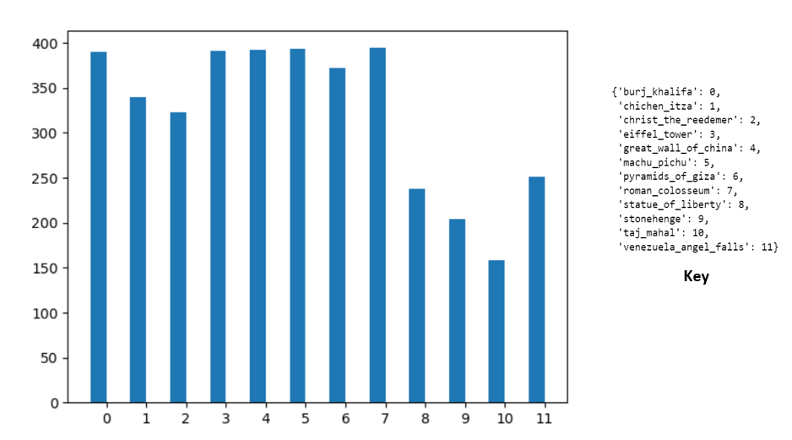

Figure 1

# 

# 

# 

# 

# 

# 

# Dataset Pre-Processing

The main preprocessing approaches used were as follows:

* Choosing the classes with balanced distribution

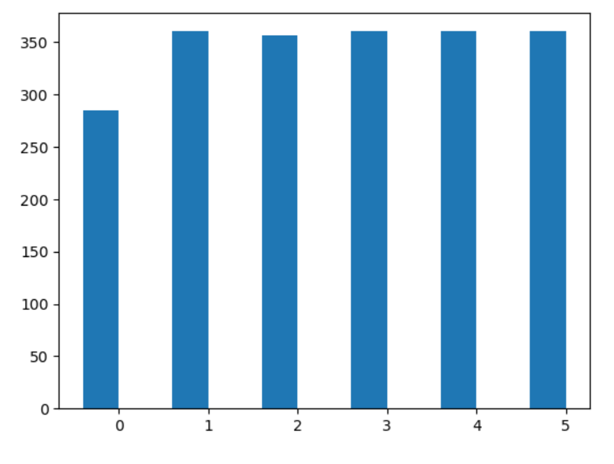

From the bar chart the chosen balanced class were are follows:

* Eiffel Tower
* Great wall of china
* Machu Pichu
* Pyramids
* Roman Colosseum

# Models Used

## DBN

## 

## 

## 

## MLP

The aim is to try multiple variations of the MLP network and evaluate their performance in classifying the wonders of the world images.

* First MLP model:
  + Model Hyperparameters:
  + Input layers: 1
  + Hidden layer: 2
  + Activation function in the hidden layer: "relu"
  + output activation function: "sigmoid"
  + optimizer: "Adam"
  + batch size= 32
  + epochs= 100
  + Model Performance:
    - Accuracy: 0.2026
    - Loss: 0.1556
    - Learning curve:

## HF

# Comparing The Models

[put the visualizations in the comparison .ipynb file]